USER AND SERVICE MANUAL
PETH-40B3

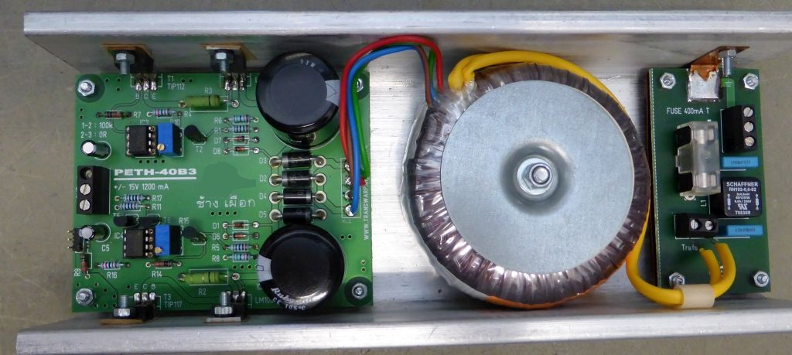

Low Noise Power Supply
for Laboratory Use
±15V, 1000mA

Design: ETH Quantumoptics, frank@phys.ethz.ch
Manufactured by ELL
Printed in ______________________ (write your location here) 24.08.2017

SAFETY WARNINGS

This device is cooled by convection. If you install it in a cabinet, make sure that the air circulation is sufficient.

This device is operated with 230 V. Make sure alle three lines are properly connected.

Replace fuse only with exact the same type. If fuse is black contact manufacturer.

If it seems that normal operation is not occurring, you must disconnect this device from the mains. Contact manufacturer for inspection.

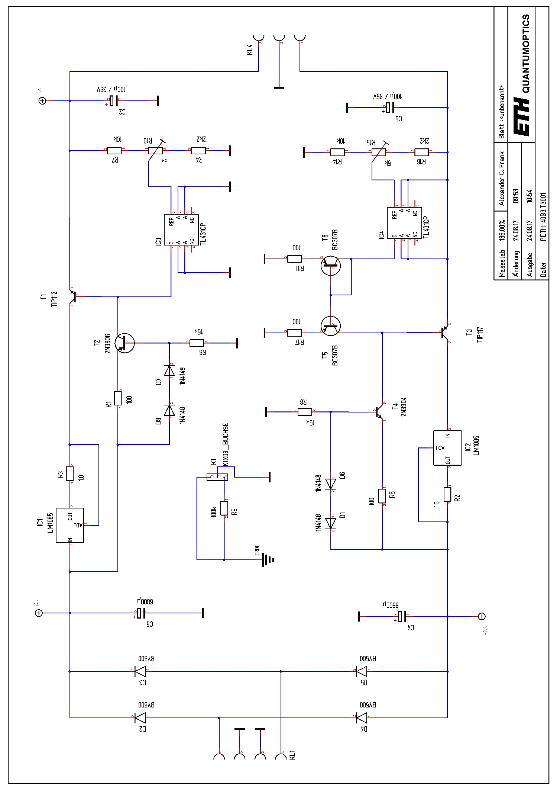
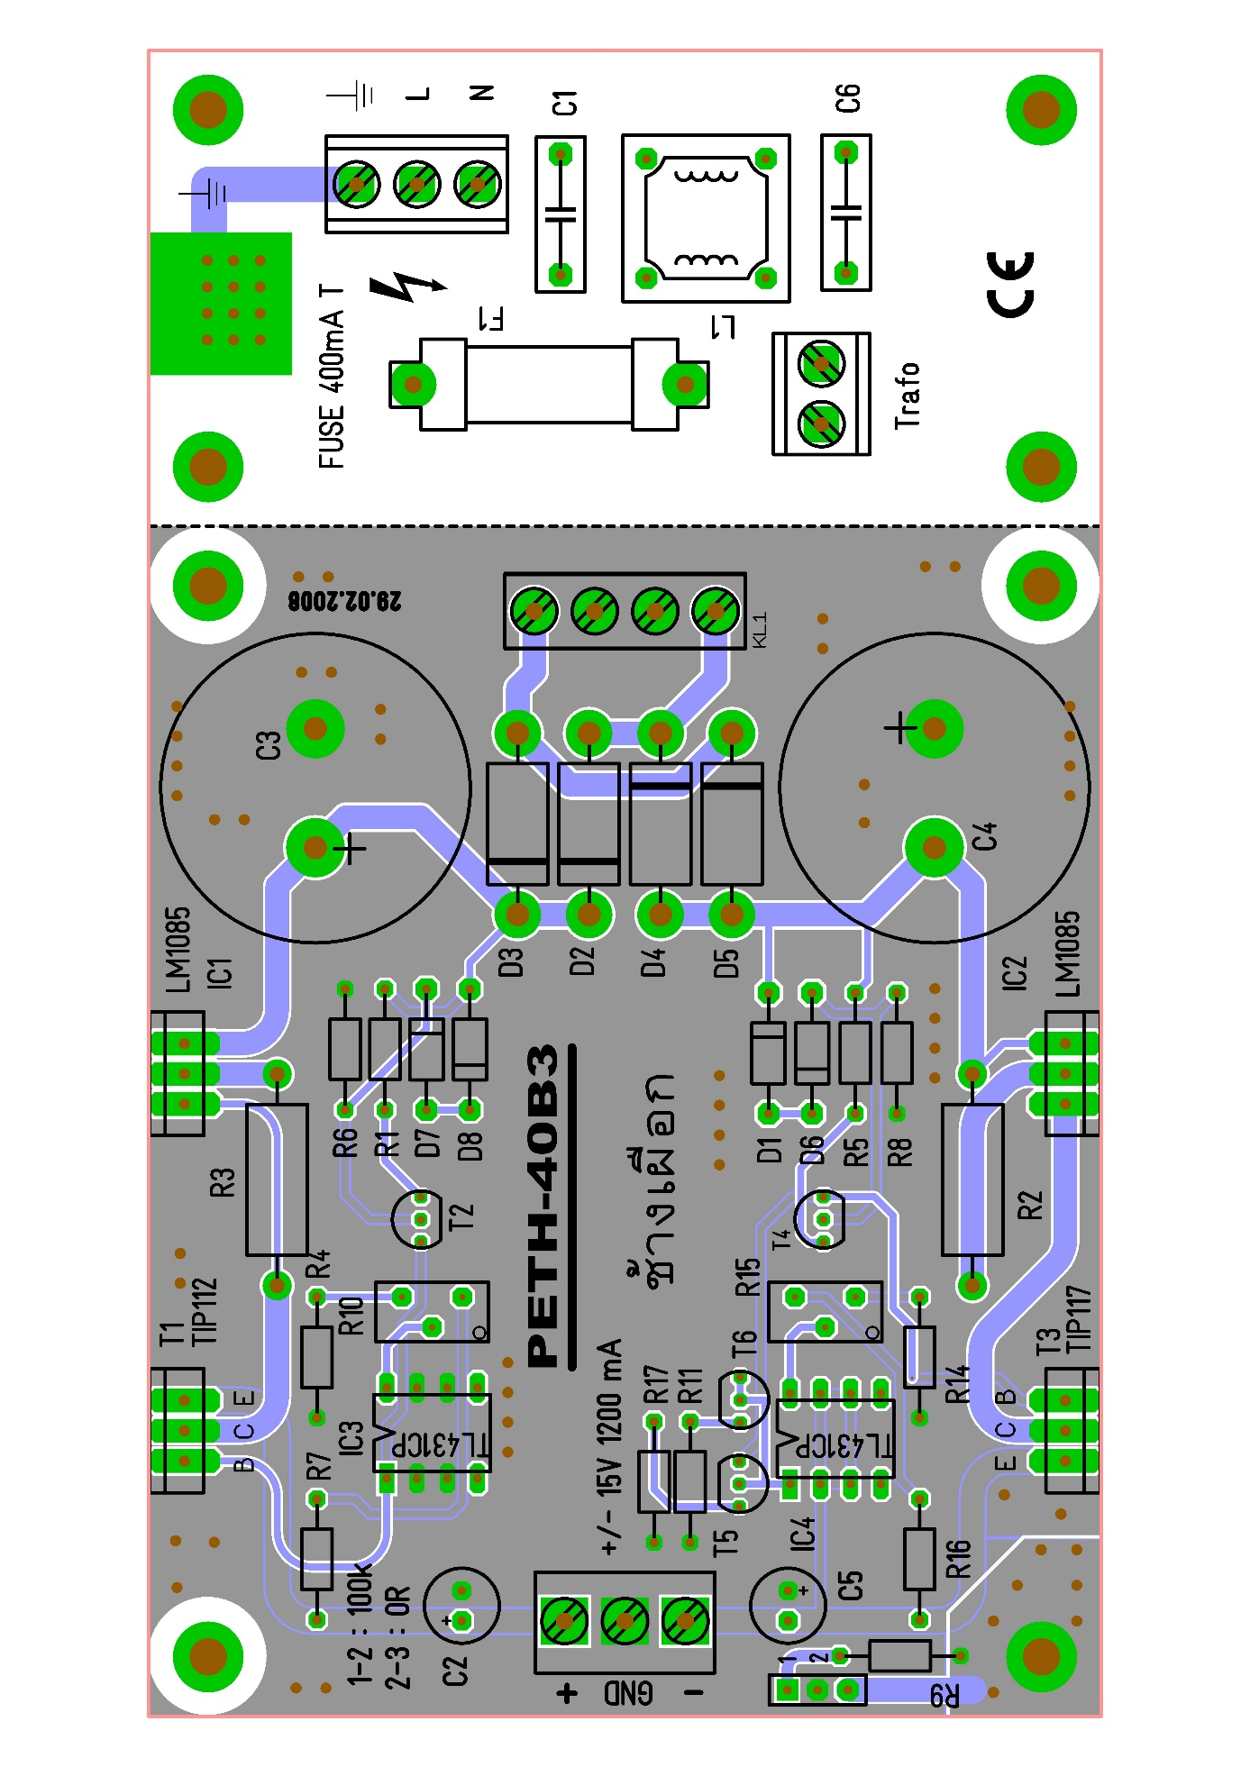

BOM
Pos | Name | Wert | Lieferant | Best.-Nr.:
1 | C1 | 10nF/275V | distrelec | 821268
2 | C2 | 100µ / 35V | B10 | 30377.4
3 | C3 | 6800µ / 35V | distrelec | 802034
4 | C4 | 6800µ / 35V | distrelec | 802034
5 | C5 | 100µ / 35V | B10 | 30377.4
6 | C6 | 10nF/275V | distrelec | 821268
7 | D1 | 1N4148 | B10 | 30002.2
8 | D2 | BY500 | distrelec | 170-00-025
9 | D3 | BY500 | distrelec | 170-00-025
10 | D4 | BY500 | distrelec | 170-00-025
11 | D5 | BY500 | distrelec | 170-00-025
12 | D6 | 1N4148 | B10 | 30002.2
13 | D7 | 1N4148 | B10 | 30002.2
14 | D8 | 1N4148 | B10 | 30002.2
15 | F1 | 400 mA T | B10 | 30073.11
16 |  | Halterung | distrelec | 271134
17 |  | Deckel | distrelec | 271138
18 |  | IC-Sockel | B10 | 30059.2
19 |  | IC-Sockel | B10 | 30059.2
20 | IC1 | LM1085/LM1086 | distrelec | 640710
21 | IC2 | LM1085/LM1086 | distrelec | 640710
22 | IC3 | TL431CP | distrelec | 649263
23 | IC4 | TL431CP | distrelec | 649263
24 | K1 | KLEMME 3POL | B10 | 30436.2
25 | KL1 | KLEMME 4POL | nicht | bestücken
26 | KL3 | KLEMME 2POL | B10 | 30436.1
27 | KL4 | KLEMME 3POL | B10 | 30436.2
28 | KL5 | KLEMME3POL | B10 | 30436.2
29 | L1 | RN102-0.6/02 | distrelec | 351517
30 | R1 | 100 | B10 | 30379.48
31 | R2 | 1.0 | B10 | 30384.1
32 | R3 | 1.0 | B10 | 30384.1
33 | R4 | 2k2 | B10 | 30380.33
34 | R5 | 100 | B10 | 30379.48
35 | R6 | 15k | B10 | 30381.4
36 | R7 | 10k | B10 | 30380.49
37 | R8 | 15k | B10 | 30381.4
38 | R9 | 100k | B10 | 30381.24
39 | R10 | 5k | farnell | 64Y-502
40 | R11 | 100 | B10 | 30379.48
41 | R14 | 10k | B10 | 30380.49
42 | R15 | 5k | farnell | 64Y-502
43 | R16 | 2k2 | B10 | 30380.33
44 | R17 | 100 | B10 | 30379.48
45 | T1 | TIP112 | Reichelt | TIP 112
46 | T2 | 2N3906 | B10 | 30007.9
47 | T3 | TIP117 | Reichelt | TIP 117
48 | T4 | 2N3904 | B10 | 30007.4
49 | T5 | BC307B | B10 | 30007.9
50 | T6 | BC307B | B10 | 30007.9
51 |  | Montageprofil | B10 | 50x100x240
52 |  | Platine | Jack ? | PETH-40B3
53 | 4 Stück | Isolierscheibe | B10 | 30050.2
54 | Trafo 1 | Ringkerntrafo | Reichelt | RKT 5015/5018
55 | diverse | Schrauben | B10 | -

NOTES

This device is designed to teach electronics by example. There are other ways (smaller BOM :-) to construct a linear Power Supply.

The GND (secondary) mayst be
- disconnected from EARTH (no jumper)
- connected via 100 kΩ (jumper left side)
- or connected via a short (jumper right side).

